Management Accounting Vs Financial Accounting
Basis for Comparison | Financial Accounting | Management Accounting
Meaning | Financial Accounting is an accounting system that focuses on the preparation of financial statement of an organization to provide the financial information to the interested parties. | The accounting system which provides relevant information to the managers to make policies, plans and strategies for running the business effectively is known as Management Accounting.
Is is compulsory? | Yes | No
Information | Monetary information only. | Monetary and non-monetary information
Objective | To provide financial information to outsiders. | To assist the management in planning and decision making process by providing detailed information on various matters.
Format | Specified | Not specified
Time Frame | Financial Statements are prepared at the end of the accounting period which is usually one year. | The reports are prepared as per the need and requirements of the organization.
User | Internal and external parties | Only internal management.
Reports | Summarized Reports about the financial position of the organization | Complete and Detailed reports regarding various information.
Publishing and auditing | Required to be published and audited by statutory auditors | Neither published nor audited by statutory auditors.

Globalization
Globalization is simply the process through which integration and interaction of countries, companies, and people across the globe. The process is as a result of the investment, outsourced manufacturing and international trade. All these are supported by information technology, with an aim of bringing economies of various countries together. It is only through globalization that people, services, and goods get to move freely across the world, in a manner that is linked and smooth.
Impact of Globalization:
- Increase Trade- greater choice of goods
- Greater choice of imports- significantly increased the choice of consumer goods.
- Increase competition/ lower prices
- Lower costs of firms
- Migration
- Economies of scale- more efficient production
- Increase capital and labour mobility
- Shifting sectors/ structural unemployment
- Tax avoidance - easier
- Growing inequality
- Environment
- Monopoly power of multinationals
Strategy
A strategy is a ‘game plan’ that enables a company to attract customers by distinguishing itself from competitors. The focal point of a company’s strategy should be its target customers.
- Customer Intimacy Strategy: Understand and respond to individual customer needs. Example: Ritz-Carlton, Nordstrom, and Starbucks.
- Operational Excellence Strategy: Deliver products and services faster, more conveniently, and at lower prices. Example: Southwest Airlines, Wal-Mart, and the Vanguard Group
- Product Leadership Strategy: Offer higher quality products. Example: BMW, Cisco System, and W.L. Gore
Activities of Accountants
An accountant performs financial functions related to the collection, accuracy, recording, analysis and presentation of a business, organization or company's financial operations.
- In a smaller business, an accountant's role may consist of primarily financial data collection, entry and report generation.
- Middle to larger sized companies may utilize an accountant as an adviser and financial interpreter, who may present the company's financial data to people within and outside of the business.
- Generally, the accountant can also deal with third parties, such as vendors, customers and financial institutions.
There are three major activities:
- Planning: Planning involves establishing a basic strategy, selecting a course of action and specifying how the action will be implemented.
  - Set objectives for achievement
  - Identify way in which objectives can be achieved
  - Make a decision as to how objectives can be achieved based on information provided
- Directing and Motivating: It involves mobilizing people to carry out plans and run routine operations.
  - Managing day-to-day activities to keep the organization running smoothly
  - Employee work assignments
  - Routine problem solving
  - Conflict resolution
  - Effective communications
- Controlling: It involves ensuring that the plan is actually carried out and its appropriately modified as circumstances change.
  - Gather information about actual results achieved
  - Compare actual results and expected results- evaluate outcome
  - Revise original objectives if necessary
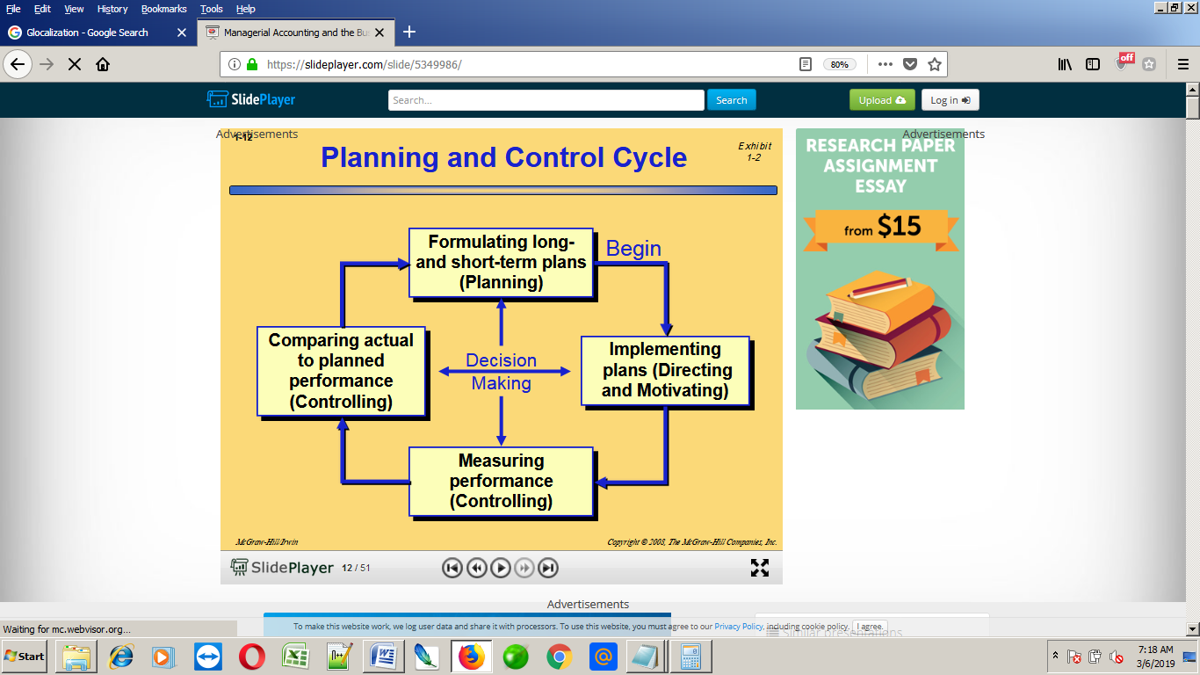
Centralization Vs Decentralization
Basis for Comparison | Centralization | Decentralization
Meaning | The retention of powers and authority with respect to planning and decisions, with the top management, is known as Centralization. | The dissemination of authority, responsibility and accountability to the various management levels, is known as Decentralization.
Involves | Systematic and consistent reservation of authority. | Systematic dispersal of authority.
Communication Flow | Vertical | Open and Free
Decision Making | Slow | Comparatively faster
Advantage | Proper coordination and Leadership | Sharing of burden and responsibility
Power of decision making | Lies with the top management. | Multiple persons have the power of decision making.
Implemented when | Inadequate control over the organization | Considerable control over the organization
Best suited for | Small sized organization | Large sized organization

Glocalization: Is a fusion of globalization and localization. By definition, the term “glocal” refers to the individual, group, division, unit, organization, and community which is willing and is able to “think globally and act locally.”
Process Management:
Process management is an integral part of any modern-day operating system (OS). The OS must allocate resources to processes, enable processes to share and exchange information, protect the resources of each process from other processes and enable synchronization among processes.
There are three approaches to improving business processes
- Lean production/Kanban System/ Just in time (JIT) Philosophy/ Zero inventory Method/ Push and pull system
- Theory of Constraints (TOC)
- Six Sigma
Lean production:
- Lean production is an approach to management that focuses on cutting out waste, whilst ensuring quality. This approach can be applied to all aspects of a business – from design, through production to distribution.
- Traditional “Push” Manufacturing Company: Work is pushed through the system in order to produce as much as possible and to keep everyone busy – even if products cannot be immediately sold. Forecast Sales-> Order components-> Store Inventory-> Produce goods in Anticipation of Sales-> Store Inventory-> Make Sales from Finished Goods Inventory
- 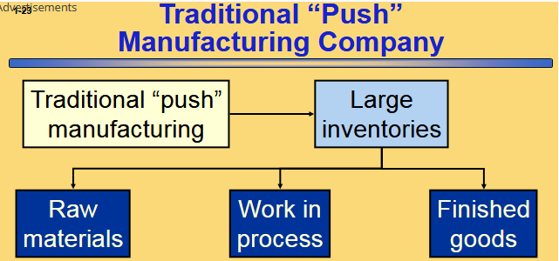
- The five step process results in a “pull” manufacturing system that reduce inventories, decreases defects, reduces wasted effort, and shorten customer response times.
- Customer Place an order-> Create Production Order-> Generate Component Requirements-> Components are Ordered-> Production Begins as Parts Arrive-> Goods Delivered when needed
- Lean thinking may be used to improve business processes that link companies together
- The term supply chain management refers to the coordination of business processes across companies to better serve end consumers.
Theory of Constraints (TOC)
- A constraint (also called a bottleneck) is anything that prevents you from getting more of want.
- The Theory of Constraints is based on the observation that effectively managing the constraints is the key to success
- The constraint in a system is determined by the step that has the smallest capacity.
- 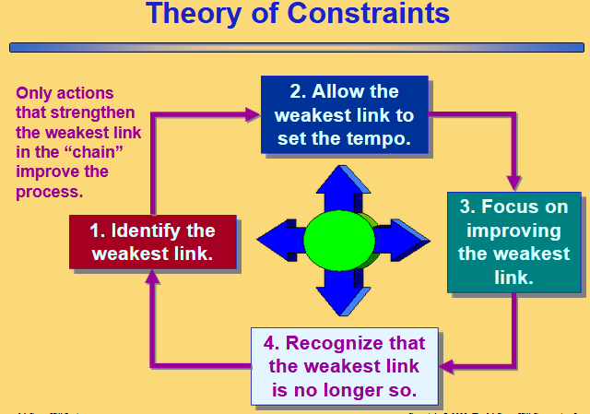
Six Sigma
- A process improvement method relying on customer feedback and fact-based data gathering and analysis techniques to drive process improvement.
- Refers to a process that generates no more than 3.4 defects per million opportunities
- Sometimes associated with the term zero defects
- Six Sigma DMAIC Framework
  - Define:
    - Establish the scope and purpose of the project
    - Diagram the flow of the current process
    - Establish the customer’s requirement for the process
  - Measure:
    - Gather baseline performance data related to the existing process
    - Narrow the scope of the project to the most important problems
  - Analyze:
    - Identify the root cause(s) of the problems identified in the measure stage
  - Improve:
    - Develop, evaluate, and implement solutions to the problems.
  - Control:
    - Ensure that problems remain fixed
    - Seek to improve the new methods over time
Task of management accounting
Managerial accounting involves collecting, analyzing, and reporting information about the operations and finances of a business. These reports are generally directed to the managers of a business, rather than to any external entities, such as shareholders or lenders. The functions of managerial accounting include:

- Margin analysis. Determining the amount of profit or cash flow that a business generates from a specific product, product line, customer, store, or region.
- Break even analysis. Calculating the mix of contribution margin and unit volume at which a business exactly breaks even, which is useful for determining price points for products and services.
- Constraint analysis. Understanding where the primary bottlenecks are in a company, and how they impact the ability of the business to earn revenues and profits.
- Target costing. Assisting in the design of new products by accumulating the costs of new designs, comparing them to target cost levels, and reporting this information to management.
- Inventory valuation. Determining the direct costs of cost of goods sold and inventory items, as well as allocating overhead costs to these items.
- Trend analysis. Reviewing the trend line of various costs incurred to see if there are any unusual variances from the long-term pattern, and reporting the reasons for these changes to management.
- Transaction analysis. After spotting a variance through trend analysis, a person engaged in managerial accounting might dive deeper into the underlying information and examine individual transactions, in order to understand exactly what caused the variance. This information is then aggregated into a report to management.
- Capital budgeting analysis. Examining proposals to acquire fixed assets, both to determine if they are needed, and what the appropriate form of financing may be with which to acquire them.

