Cost Object: A cost object is anything for which cost data are desired – including products, product lines, customers, jobs and organizational subunits.
Objectives of Cost Accounting
- Determining selling price
- Controlling cost
- Providing information for decision making
  - Determination of cost-volume-profit relationship
  - Make or buy component
  - Shut down or continue operation at a loss
  - Continuing with the existing machinery or replacing them by improved
- Ascertaining costing profit
- Facilitating preparation of financial or other statements
Cost Classification
- Financial Reporting ( showing the profit)
- Predicting Cost Behavior – variable or fixed
- Assigning costs to cost object as departments or products – direct or indirect
- Making Business Decisions
Merchandising Vs Manufacturing Activities
Merchandising | Manufacturing Activities
Buy Finished goods | Bye raw materials
Sell finished goods | Produce and sell finished goods

Classification of Manufacturing Cost
Manufacturing Costs (also called product Costs or Inventoriable Costs)
- Direct Materials: Those materials that become an integral part of the product and that can be conveniently traced directly to it. Cost of these materials can be directly traced to outputs. Example: Publishing company( Paper, ink, book covers), Automobile Manufacturer(Tires, automobile metal parts)
- Direct Labor: Labor cost that can be physically and conveniently traced to a product (such as assembly-line workers in a plant). Direct labor is sometimes called touch labor
- Manufacturing Overhead: Manufacturing costs that cannot be traced directly to specified units produced. All costs of manufacturing a product other than direct materials and direct labor.
  - Indirect labor: Wages paid to employees who are not directly involved in production work.
  - Indirect materials: Material used to support the production process. Example: lubricants and cleaning supplies used in the automobile assembly plants
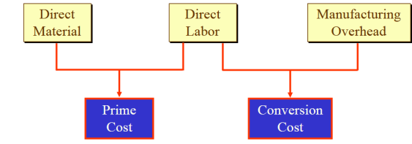
Non-manufacturing Costs (also called Period Costs)
- Marketing or Selling Costs: All costs necessary to secure customer orders and get the finished product or service into the hands of the customer ( such as sales commissions, advertising and depreciation of delivery equipment and finished goods warehouse)
- Administrative Costs: All costs associated with the general management of the company as a whole ( such as executive travel costs, secretarial salaries and depreciation of office buildings and equipment)
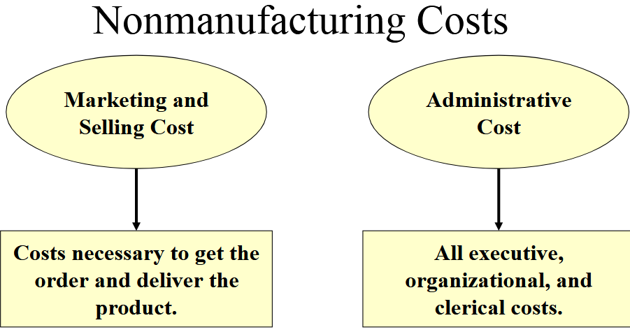

https://www.slideshare.net/Abu_Islam/chapter-2-cost-terms-concepts-and-classifications-2012-students1
https://www.slideshare.net/malinga_perera/3-cost-terms-concepts-and-classifications
https://slideplayer.com/slide/5117872/

